Lab2 Report

Route Configuration

Student: 陳孟楷
Student ID: 113550021

December 2024

- Execution
- How to run your program in Task 4?
At first, I ran myTopo.py by inputting “sudo mn –custom myTopo.py –topo topo link tc –controller remote” in one terminal, and I ran myController.py by inputting “ryu-manager myController.py --observe-links” in another terminal.
In the first terminal, I opened two nodes (h1 and h2) by inputting “xterm h1 h2”.
For sending UDP packets, I inputted “iperf -s -u -i 1 -p 5566” to listen UDP transmission in h1 and sent UDP packets by inputting “iperf -c 10.0.0.1 -u -i 1 -p 5566” in h2.
For sending TCP packets, I inputted “iperf -s -i 1 -p 5566” to listen TCP transmission in h1 and sent TCP packets by inputting “iperf -c 10.0.0.1 -i 1 -p 5566” in h2.
At last, I left myTopo.py by inputting “exit” in terminal 1 and typed “ctrl-z” to leave myController.py. Then I cleaned up Mininet by inputting “sudo mn -c”.

- What is the meaning of the executing command in previous question?
For “sudo mn –custom myTopo.py –topo topo link tc –controller remote”, --custom myTopo.py means to specify myTopo.py that defines a topology for the network. --topo topo means to use a specific topology defined in myTopo.py. link tc means to enable the traffic control for the links. --controller.remote means to connect Mininet to a remote SDN controller.
For “ryu-manager myController.py --observe-links”, --observe-links means to enable link discovery and build a topology map. “xterm h1 h2” means open terminal for h1 and h2.
For “iperf -s -u -i 1 -p 5566”, -s means to run in server mode, -u means to use UDP, -i 1 means to display bandwidth statistic every second. -p 5566 means to set the server port to 5566. For “iperf -c 10.0.0.1 -u -i 1 -p 5566”, -c 10.0.0.1 means to specify the server’s IP address. Other commands are the same as “iperf -s -u -i 1 -p 5566”.
For “iperf -s -i 1 -p 5566” and “iperf -c 10.0.0.1 -i 1 -p 5566”, commands are the same as UDP transmission except for removing the -u which means to use UCP to send.

- Screenshot of the Task 4
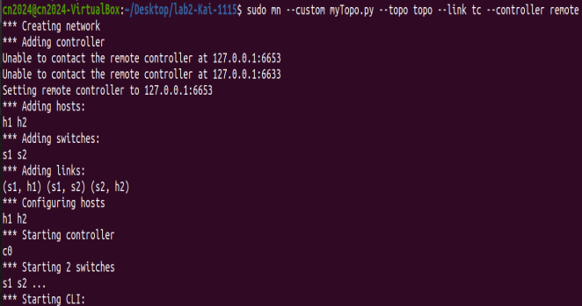
Figure 1. Mininet

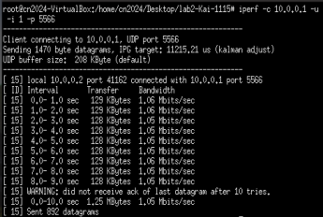
Figure 2. Sending UDP packets

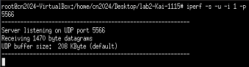
Figure 3. Listen UDP transmission

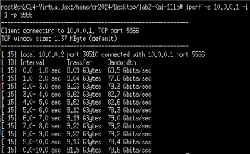
Figure 4. Send TCP packets

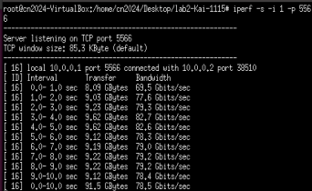
Figure 5. Listen TCP transmission

- Description
- Describe how you finish this work in detail?
First, I downloaded the ova file and imported it into virtual machine. Second, I cloned all files from GitHub and tested Mininet. Third, I cloned two files named myTopo.py and myController.py from exampleTopo.py and exampleController.py. From two example Python files, I learned how to add host/switch/link and how to modify forwarding rules of the router. Therefore, I added one more router, modified the link between h1, s1, s2, and h2, added the forwarding rules for switch 2, and used the command “ip_proto=6,” to only allow TCP packets to be transmitted. Afterwards, I followed the steps in the slides to create UCP/TCP connections.
- Which reference you refer to?
- Slides provided by the professor and TAs.
- iPerf Commands https://iperf.fr/iperf-doc.php
- Mininet Commands http://mininet.org/walkthrough/

- Discussion
- Describe the difference between packet-in and packet-out in detail.
Packet-in is sent from the switch to the controller usually happened when the switch wants to notify the controller something, while packet-out is sent from the controller to the switch usually happened when the controller wants to instruct the switch to tackle a specific packet.
- What is “table-miss” in SDN?
Table-miss happens when the switch receives a packet, and this packet doesn’t match any flow in the flow table. When table-miss occurs, it may send the packet to the controller, drop the packet, or forward to a specific port.

- What is the meaning of “datapath” in controller.py?
Datapath refers to the logical representation of a switch in Ryu SDN framework. It’s a Python object that abstract switches’ data planes and provides some attributes. In myController.py, for example, datapath.id == 1 represents the switch 1, while datapath.id == 2 represents the switch 2.
- Compare the differences between the iPerf results of exampleController.py and myController.py in detail.
The difference between two Python files is mostly on UDP transmission. For exampleController.py, UDP packets can be received successfully. For myController.py, however, UDP packets cannot be received successfully since we added the rule that only allows TCP packets to be transmitted.

- Bonus
- What have you learned from this lab?
In this lab, I learned how to design my own SDN. In myTopo.py, I learned how to add a host/switch/link in the topology. In myController.py, I learned how to adjust the forwarding rules of each switch. Also, I used some knowledge learned from lab1 to create and listen TCP/UDP connections using iPerf.
- What difficulty have you met in this lab?
Since I’m not familiar with the commands given in the slides, I spent a little time to realize the concepts and objectives of each command at first. Furthermore, I don’t know how to only allow TCP packets to be transmitted. Therefore, I googled it and found that I can use “ip_proto=6,” to only allow TCP packets to be transmitted.

